**LAB REPORT**

**IT3080E COMPUTER NETWORKS**

**gROUP 1**

**NGUYỄN DUY AN – 20214943**

**NGUYỄN HOÀNG ANH – 20214945**

**phùng đình gia huy – 20214960**

**VŨ HOÀNG NGỌC - 20210646**

## Report for lab 3

**5.3.1 Connecting two LANs using routers**

**Question 1 (1 pt):** Assign suitable IP address to sg-workstation, hn-workstation and network interfaces of routers. Fill these address into the network topology.

IP of hn-workstation: 192.168.1.10 Mask:255.255.255.0

IP of sg-workstation: 192.168.2.2 Mask: 255.255.255.0

IP of Hanoi-eth0:192.168.1.1 Mask: 255.255.255.0

IP of Hanoi-eth1:10.10.1.1 Mask:255.255.0.0

IP of Saigon-eth0: 192.168.2.1 Mask: 255.255.255.0

IP of Saigon-eth1: 10.10.2.1 Mask:255.255.0.0

*Fill the address to the bellow Figure.*

Figure 3: Network topology.

**Question 2 (1 pt)**: Enable the network interfaces of workstations and assign the IP address as specified in Question 1 using the ifconfig statement. The commands to use are:

On hn-workstation:

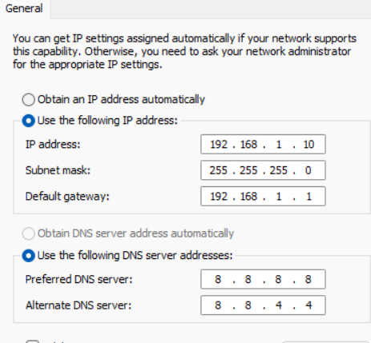

On sg-workstation:

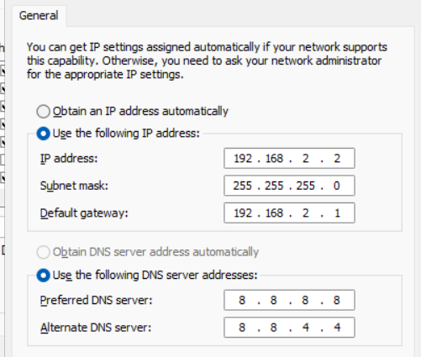

**Question 3 (1 pt)**: Setup routing rules on workstations

Use route –n to check the routing table

Use route add to add a new route to a distance network.

Write down the command to be executed on **hn-workstation** to forward data to Saigon network:

sudo route add -net 192.168.2.0 netmask 255.255.255.0 gw 10.10.2.1

Write down the command to be executed on **sg-workstation** to forward data to Hanoi network:

sudo route add -net 192.168.1.0 netmask 255.255.255.0 gw 10.10.1.1

**Question 4 (1 pt):** Execute the command to set the IP address for the interfaces connected to the LAN of the Hanoi router:

Sudo ifconfig enx000ec6648898 192.168.1.1 netmask 255.255.255.0 up

And Saigon router:

Sudo ifconfig enx000ec6648884 192.168.2.1 netmask 255.255.255.0 up

Execute the command to set IP address for the interfaces connected to the leased line of the Hanoi router:

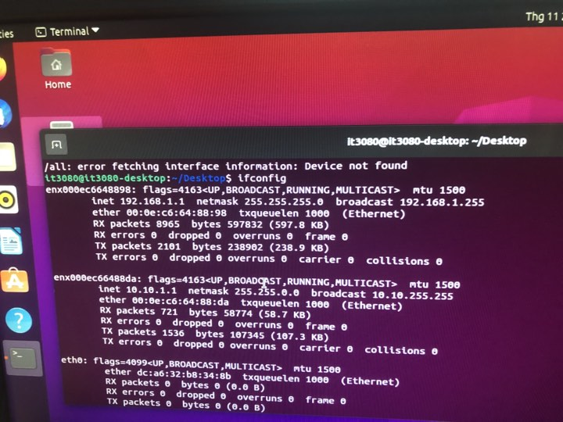

And Saigon router:

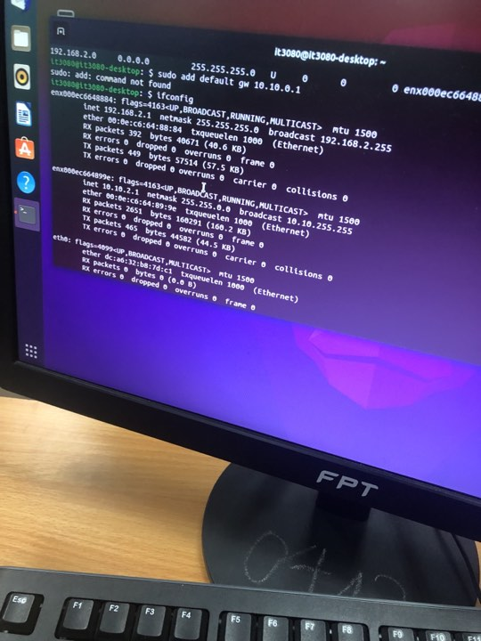

**Question 5 (1 pt):** Execute the command on the Hanoi router to add the routing rule to destinations in Saigon network:

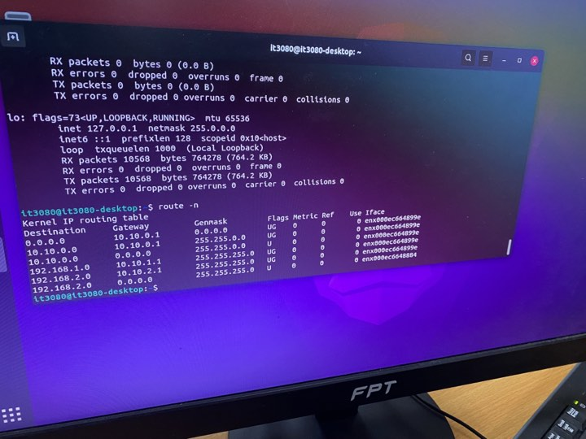

Execute the command on the Saigon router to add the routing rule to destinations in Hanoi networks: 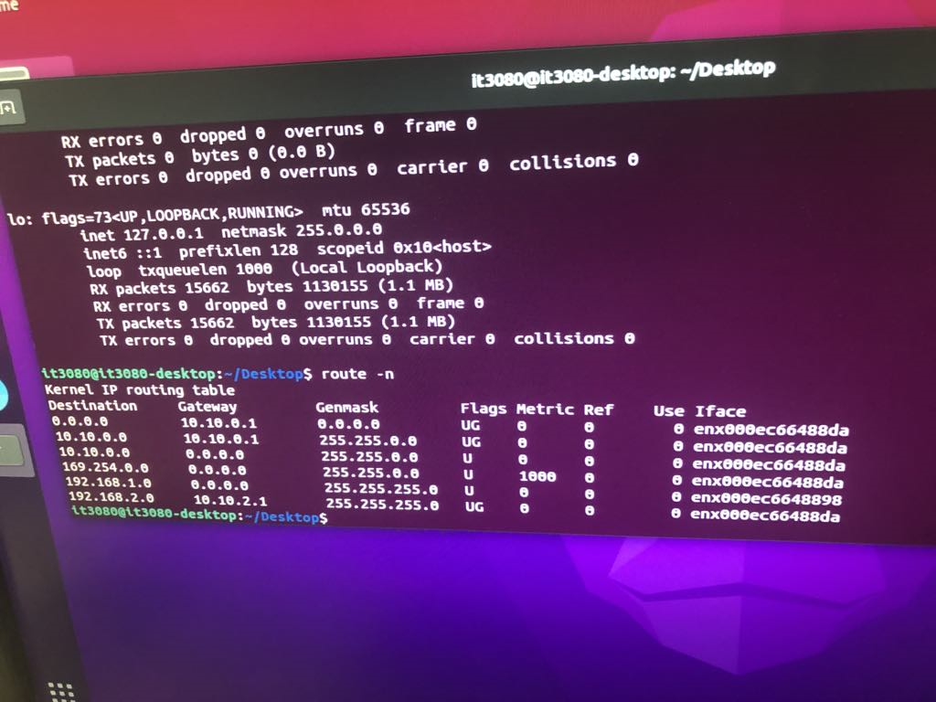

**PC1 -> R1 (in)**

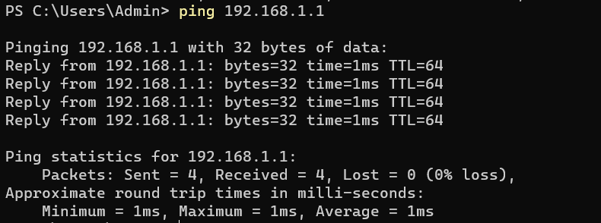

**PC1 -> R1 (out)**

